**Front-End Developer Challenge and Questions**

We realize there are often multiple solutions or answers to the same questions and to the challenge in particular. We do not necessarily have “right or wrong” in mind, we are simply looking to learn a bit about you, and your approach to development.

**Questions:**

**What front-end component libraries or frameworks have you used besides bootstrap?**

Ans: Angular material

**What tools would you implement to enforce code quality rules and standards?**

Ans: TSLint

**What HTML templating languages or engines have you used?**

Ans: EJS, PUG, Mustache

**Which code related blogs or sites do you read regularly?**

StackOverFlow,Medium,Linkedin,Youtube,Google

**In Sass, what is the significance of using an underscore at the beginning of a sass file name?**

Ans: If you add an underscore to the start of the file name, Sass won’t compile it. So, if you don’t want colors.scss to compile to colors.css, name the file _colors.scss instead. Files named this way are called partials in Sass terminology.

**Name a few (npm) node modules that you think are most useful?**

Ans:

@angular/core,  
 @angular/http,  
 @angular/router,  
 @ngx-translate/core,  
 @ngx-translate/http-loader,

zone.js,

rxjs,  
@types/body-parser

@types/boom,  
@types/compression,  
@types/cors,  
@types/express,

**Given the option to choose Angular, React or Vue.js for a new project which would you choose and why? What type of requirements might affect your decision to use one over the other?**

Ans:

If you work with Google related applications: Angular

If you love TypeScript: Angular (or React)

If you love object-orientated-programming (OOP): Angular

If you need guidance, structure and a helping hand: Angular

If you work at Facebook related applications: React

If you like flexibility: React

If you love big ecosystems: React

If you like choosing among dozens of packages: React

If you love JS & the “everything-is-Javascript-approach”: React

If you like really clean code: Vue

If you want the easiest learning curve: Vue

If you want the most lightweight framework: Vue

If you want separation of concerns in one file: Vue

If you are working alone or have a small team: Vue (or React)

If your app tends to get really large: Angular (or React)

If you want to build an app with react-native: React

If you want to have a lot of developers in the pool: Angular or React

If you work with designers and need clean HTML files: Angular or Vue

If you like Vue but are afraid of the limited ecosystem: React

If you can’t decide, first learn React, then Vue, then Angular.

**If you were referred to an unfamiliar node project repo, what file or files would you first look to, to determine the commands to run, build and test the project?**

Ans: Package.json

**What is the benefit of using the HTML ‘nav’ element vs. a div with the class of .nav?**

Ans: A <nav> is a fairly new [HTML element](http://www.w3.org/wiki/HTML/Elements/nav) defined in HTML5. It's meant for more semantic markup (letting the browser know) that those links aren't just normal links, they are a **navigation** menu. This can be useful for accessibility (screen readers, mobile devices with small screens) and other things. With Div tag and .nav class browser understands them as links rather than navigation items.

**What code related framework, library or language do you want to learn next?**

Ans: Angular6,Java9, React, Solidity (Ethereum Blockchain)

**Challenge:**

Using the latest version of Bootstrap, create a single, web page that collapses responsively from desktop to mobile and where the desktop and mobile breakpoints match the wireframe images provided.

Utilize the Bootstrap grid system, components, and classes. Take care to demonstrate the use of modern, semantic HTML elements.

The carousel at the top of the page should contain three slides – which can all display the same content, but the carousel itself should be functional in that clicking left or right will animate to the previous or next slide.

Additionally, in the mobile view, the “hamburger” (three lines icon) menu button should collapse and expand the navigation.

All other components are only present for layout purposes and do not need to function - navigation links do not need to lead anywhere, search does not need to work, and so on.

Please find below screenshots

Regular view:

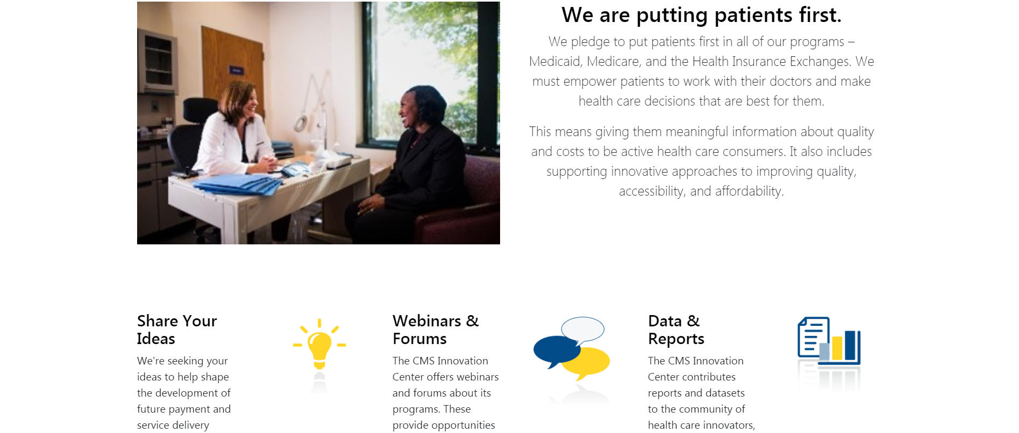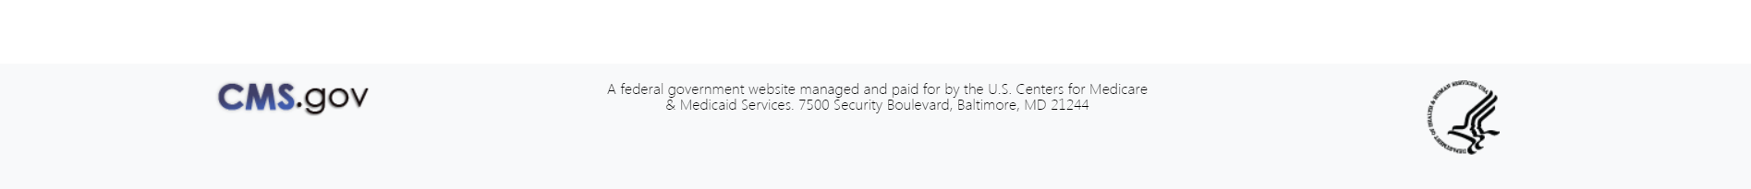

Mobile view:



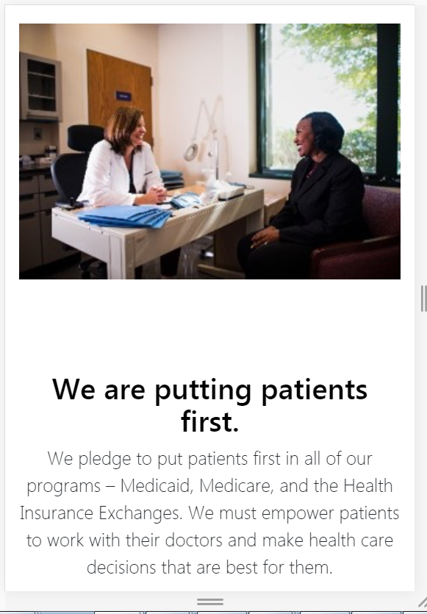



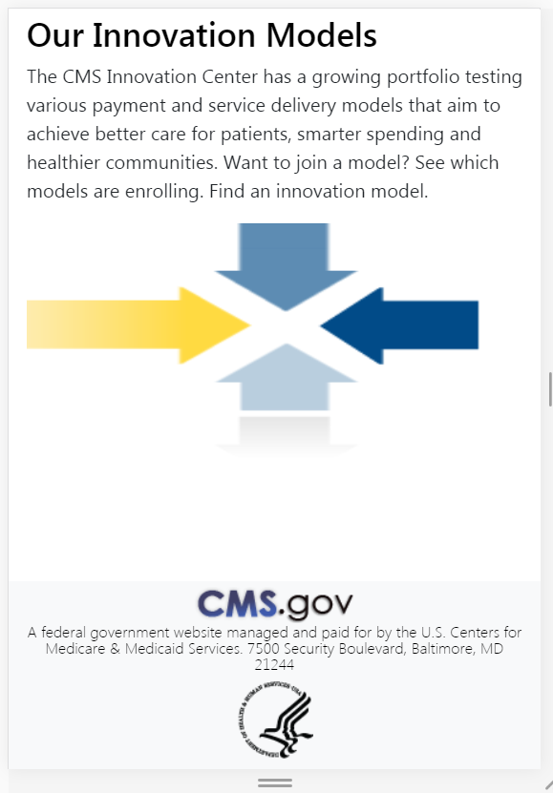

**Challenge Setup:**

At a minimum, you must utilize Sass to import Bootstrap via your choice of any build tool (Gulp, Webpack, Parcel etc) or CLI to create the HTML and CSS output. The output should be locally viewable by simply loading an index.html page into the browser.

Use whatever tools you are most comfortable with to accommodate this, you do not have to reinvent the wheel.

Combine all of your challenge directory/files as well as this document with completed answers in a single .zip file and deliver back to us as soon as you have completed them.

Please provide your entire directory structure (with the exception of node_modules if it is generated by your toolset) to keep totally delivery size small.

Feel free to contact us with any questions and thank you for taking the time to complete these items!

Technologies used:

Angular 6 , SCSS, TypeScript 2.7, Bootstarp 4 , JQuery 3, font awesome, Webpack , Angular CLI